**CHARTING THE COURSE OF INNOVATION:**

**STARTUP ANALYSIS**

**INTRODUCTION**

Starting new business in the modern world is not easier it is highly completed and risky. We need a correct planning and analysis of our business to enrich our company stability and visible profit. To gain profit we need various analytical skills and knowledge in market. Which can be achieved easily using the tableau yes we are using the concept of tableau over excel here.

**Overview**

**TABLEAU**

Tableau was found in 2003 to enrich the business but I become one the business strategy. As the market leading choice for modern business platform makes it easier for the people to explore and manage data and faster to discover and share insights that can business and the world.

**DEFINE PROBLEM**

First we to identify and specifies the business problems for the requirement of the business ,we can collect the KPIs of the different state ,industry and latest item and drawbacks in the affected and with this collected date we can create the report to identify the area for improvement and get the idea of developing the affected.

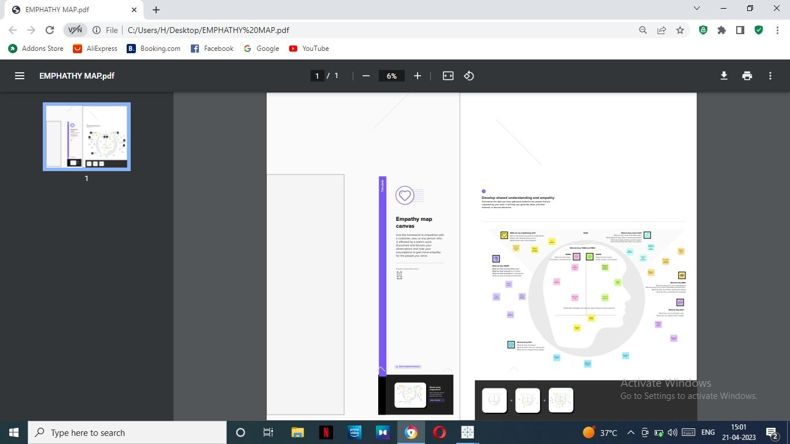**EMPATHY MAP**

It is a collaborative tool teams can use to gain a deeper insight into their customers. Much like a user persona, an empathy map can represent a group of users, such as a customer segment. The empathy map was originally created by Dave Gray and has gained much popularity within the agile community.

**Use of empathy map**

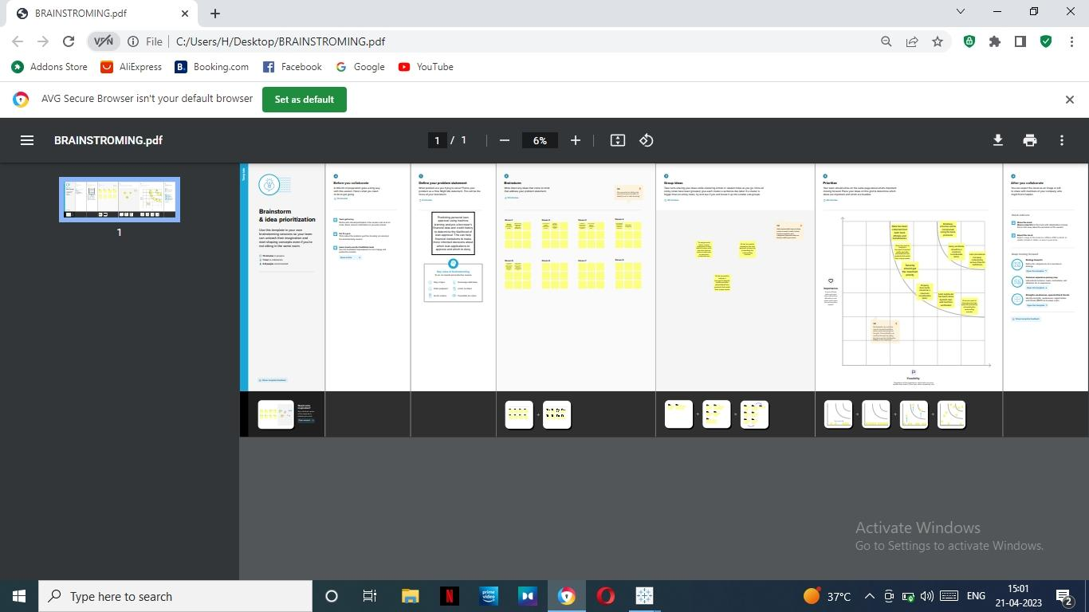

An empathy map helps to map what a design team knows about the potential audience. This tool helps to understand the reason behind some actions a user takes deeply. This tool helps build Empathy towards users and helps design teams shift focus the product to the users who are going to use the product

**fig: empathy map**

**BRAINSTORM**

Brainstorm can use people to analyse the various problem and discuss under the different condition to get the various solution. All in the team can able to discuss the idea of solution problem.

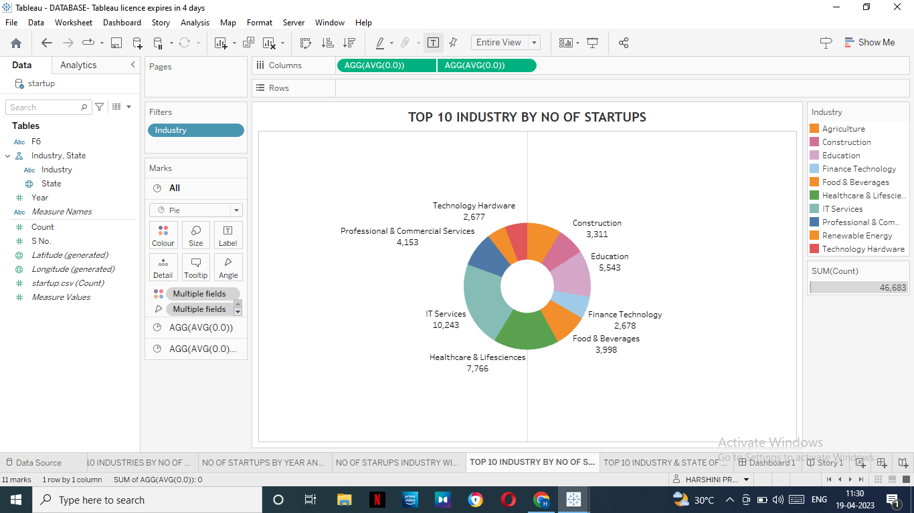

**fig:brainstrom**

**DATACOLLECTION** & **EXTRACTION FROM DATABASE**

Data collection is the collection data from various sour and measuring information Hera the data contain all the type of information in the form of comma separated values that is CSV files now the given data need to be formed as column here the column describes the months may, June and July. Columns stores the data in mmm yyyy format and gives the week number for particular data and the given week is weekend or not then stored the performed data in database and connect the database to tableau.

**DATA PREPARATION**

Now we can use processed data to get the visual bar graph,for this involve adding the missing data and removing irrevelent preparing visualization we can ensure the accuraence of days and complete.

**DATA VISUALIZATION**

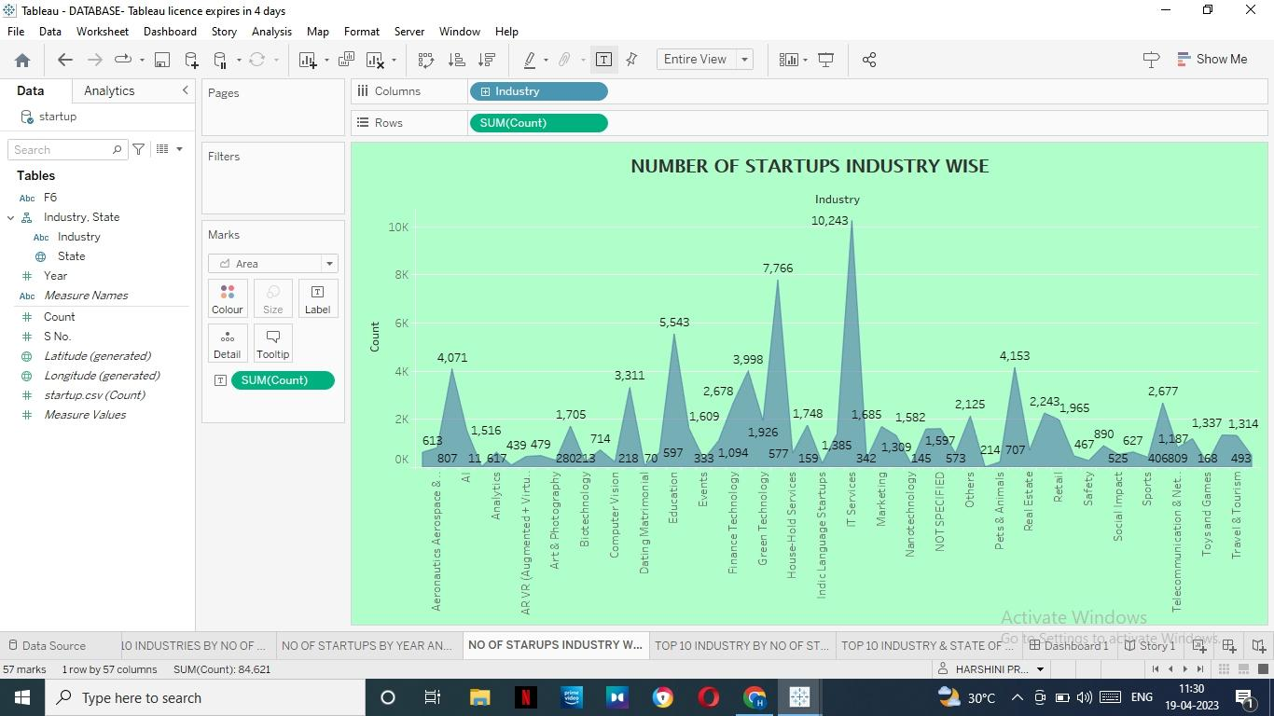

Fig: Number of startups industry wise

Data visualization is the process of creating the pictorical representation of the processed data to help the people to understand the data more and more easier and it makes the more completed data to understand easily even for uneducated and easy interput. Visual element such ascharts, graphs and maps data visualization can help people quickly identify pattern 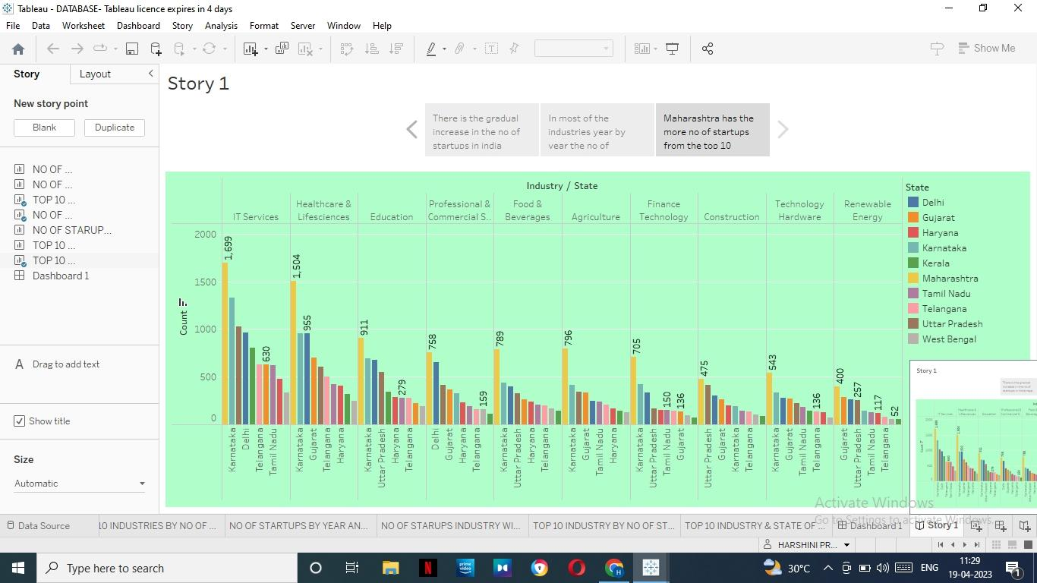and terms.

Fig: Number of startup by year and applying filters of industries and state

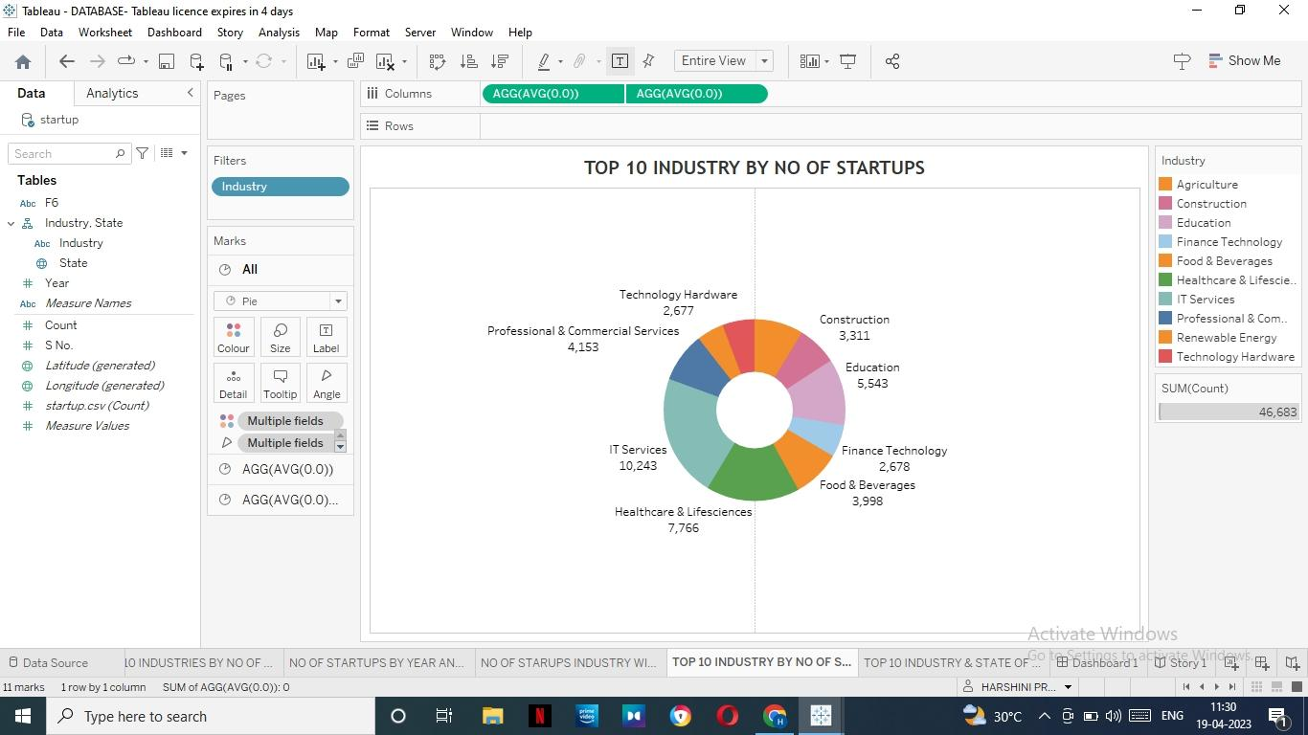

**Fig: Top 10 industries by no of startups**

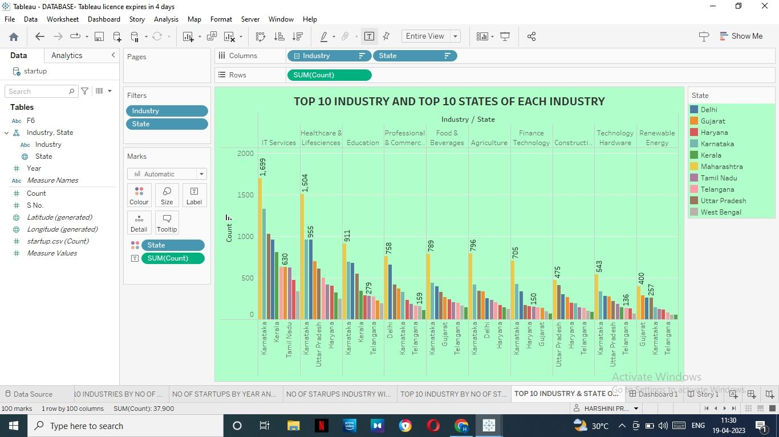**Fig : TOP 10 INDUSTRIES AND TOP 10 STATES OF EACH INDUSTRY**

**DASHBOARD**

A dashboard is an information management tool that receives data from a linked database to provide data visualizations. It typically offers high-level information in one view that end users can use to answer a single question.

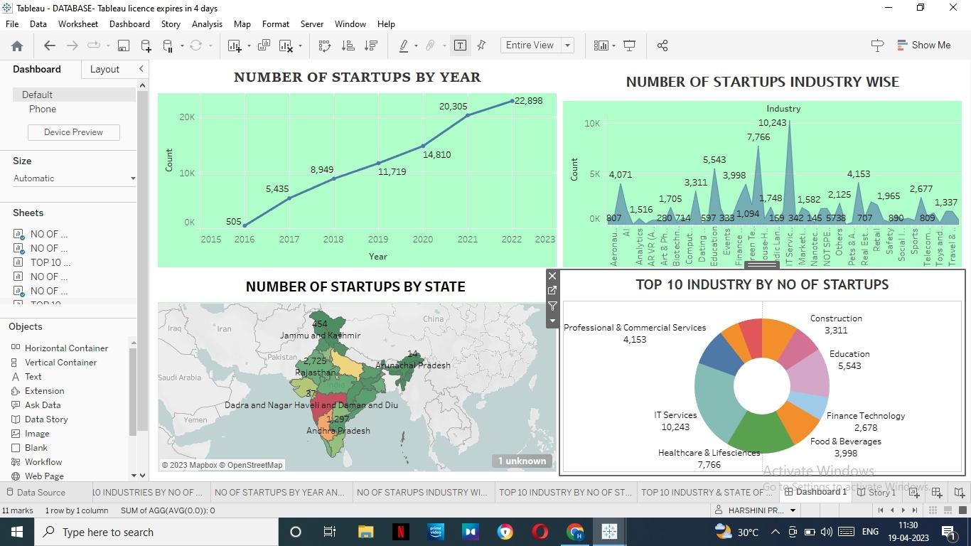**Fig: Responsive and design of dashboard**

Dashboard can be used in variety of settings such as business,manufacture for the specific performance

**LINK**

Link: div class='tableauPlaceholder' id='viz1682070072836' style='position: relative'><noscript><a href='#'><img alt='Dashboard 1 ' src='https:&#47;&#47;[public.tableau.com](http://public.tableau.com/)&#47;static&#47;images&#47;DA&#47;DASHBOARD_16820128734990&#47;Dashboard1&#47;1_rss.png' style='border: none' /></a></noscript><object class='tableauViz'  style='display:none;'><param name='host_url' value='https%3A%2F%[2Fpublic.tableau.com](http://2fpublic.tableau.com/)%2F' /><param name='embed_code_version' value='3' /><param name='site_root' value='' /><param name='name' value='DASHBOARD_16820128734990&#47;Dashboard1' /><param name='tabs' value='no' /><param name='toolbar' value='yes' /><param name='static_image' value='https:&#47;&#47;[public.tableau.com](http://public.tableau.com/)&#47;static&#47;images&#47;DA&#47;DASHBOARD_16820128734990&#47;Dashboard1&#47;1.png' /><param name='animate_transition' value='yes' /><param name='display_static_image' value='yes' /><param name='display_spinner' value='yes' /><param name='display_overlay' value='yes' /><param name='display_count' value='yes' /><param name='language' value='en-GB' /></object></div>                <script type='text/javascript'>                    var divElement = document.getElementById('viz1682070072836');                    var vizElement = divElement.getElementsByTagName('object')[0];                    if ( divElement.offsetWidth > 800 ) { vizElement.style.width='100%';vizElement.style.height=(divElement.offsetWidth*0.75)+'px';} else if ( divElement.offsetWidth > 500 ) { vizElement.style.width='100%';vizElement.style.height=(divElement.offsetWidth*0.75)+'px';} else { vizElement.style.width='100%';vizElement.style.height='1227px';}                     var scriptElement = document.createElement('script');                    scriptElement.src = '<https://public.tableau.com/javascripts/api/viz_v1.js>';                    vizElement.parentNode.insertBefore(scriptElement, vizElement);                </script>

<https://public.tableau.com/views/DASHBOARD_16820128734990/Dashboard1?:language=en-GB&:display_count=n&:origin=viz_share_link>

**STORY**

A story map is a graphic organizer that helps students learn the elements of a narrative. Learning to identify a story's characters, plot, setting, problem, and solution prompts students to read carefully to learn the important details. There are many different types of story maps. It tends to explain the data in various visualization form such as representation, interactive, video

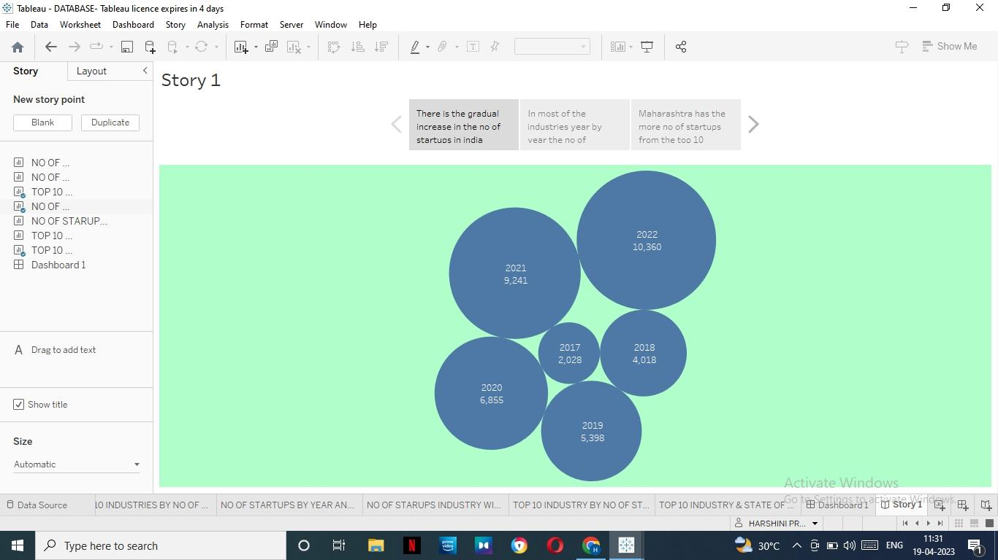

Fig: No of startups by year and applying fliters of industry and state

**LINK**

https://public.tableau.com/views/STORY_16820138899000/Story1?:language=en-GB&:display_count=n&:origin=viz_share_link

**ADVANTAGE**

**Data visualization**

Tableau is a data visualization tool first and foremost. Therefore, it’s technology is there to support complex computations, data blending and dashboarding for the purpose of creating beautiful visualizations that deliver insights that cannot easily be derived from staring at aspread sheet. It has climbed to the top of the data visualization heap because of it’s dedication to this purpose

**Quickly Create Interactive visualizations**

Using drag-n-drop functionalities of Tableau, the user can create a very interactive visual within minutes. The interface can handle endless variations while also limiting you from creating charts that are against data visualization best practices. You can check out some of the amazing visuals created a tensure that the right report is served to the right device

**Tableau Company Strategy**

Tableau has done a great job climb its way to the top of data visualization tools. So, according to Garner Magic Quadrant. Tableau has spent more than six years as a leader. However, with the increasing interest in data science, artificial intelligence, and machine learning, Tableau may be left behind if it doesn’t innovate quickly. You can see from the issues with 2017 financials reporting Forbes concerns with Tableau profitability

**DISADVANTAGES**

**Scheduling or notification of reports**

Tableau does not provide the feature of automatic refreshing of the reports with the help of scheduling. There is no option of scheduling in Tableau. Therefore, there is always some manual effort required when users need to update the data in the back-end.

**No Custom Visual Imports**

Tableau is not a complete open tool. Unlike other tools like Power BI, developers can create custom visuals that can be easily imported Tableau. So, any new visuals need to be recreated instead of imported.. Custom formatting in Tableau

**Custom formatting in Tableau**

Tableau’s conditional formatting and limited 16 column table displays are pain points for users. Also, to implement the same formatting to multiple fields there is no way a user can do that for all fields directly. Users need to do that manually for each field which is very time consuming.

**Limited Data Preprocessing**

Tableau is strictly a visualization tool. Tableau Desktop allows you do to very basic preprocessing. This includes joining and blending data. Also, you have the ability to change data types

**Scaling and Pricing for Enterprise**

This is the biggest issue with Tableau, it’s a very expensive product to scale across a large organization. Compared to cheaper and more well rounded BI tools. Tableau one of the more expensive option. For security and sharing, the only option is Tableau Server which can $175,000 for an 8 core option and $35 dollars per user. Alternatively, you can use Tableau Online which is limited but is $35 per user. This can accumulate if you are trying to have a large number of users access reports

**APPLICATION IN REAL LIFE**

It helps users create different charts, graphs, maps, dashboards, and stories for visualizing and analyzing data, to help in making business decisions.

**CONCLUSION**

From this can understand breifley about the tableau and using of this tableau can able to bring the revolution in the business world. By using this concept as further in futue we may able to develop our business to the profitable